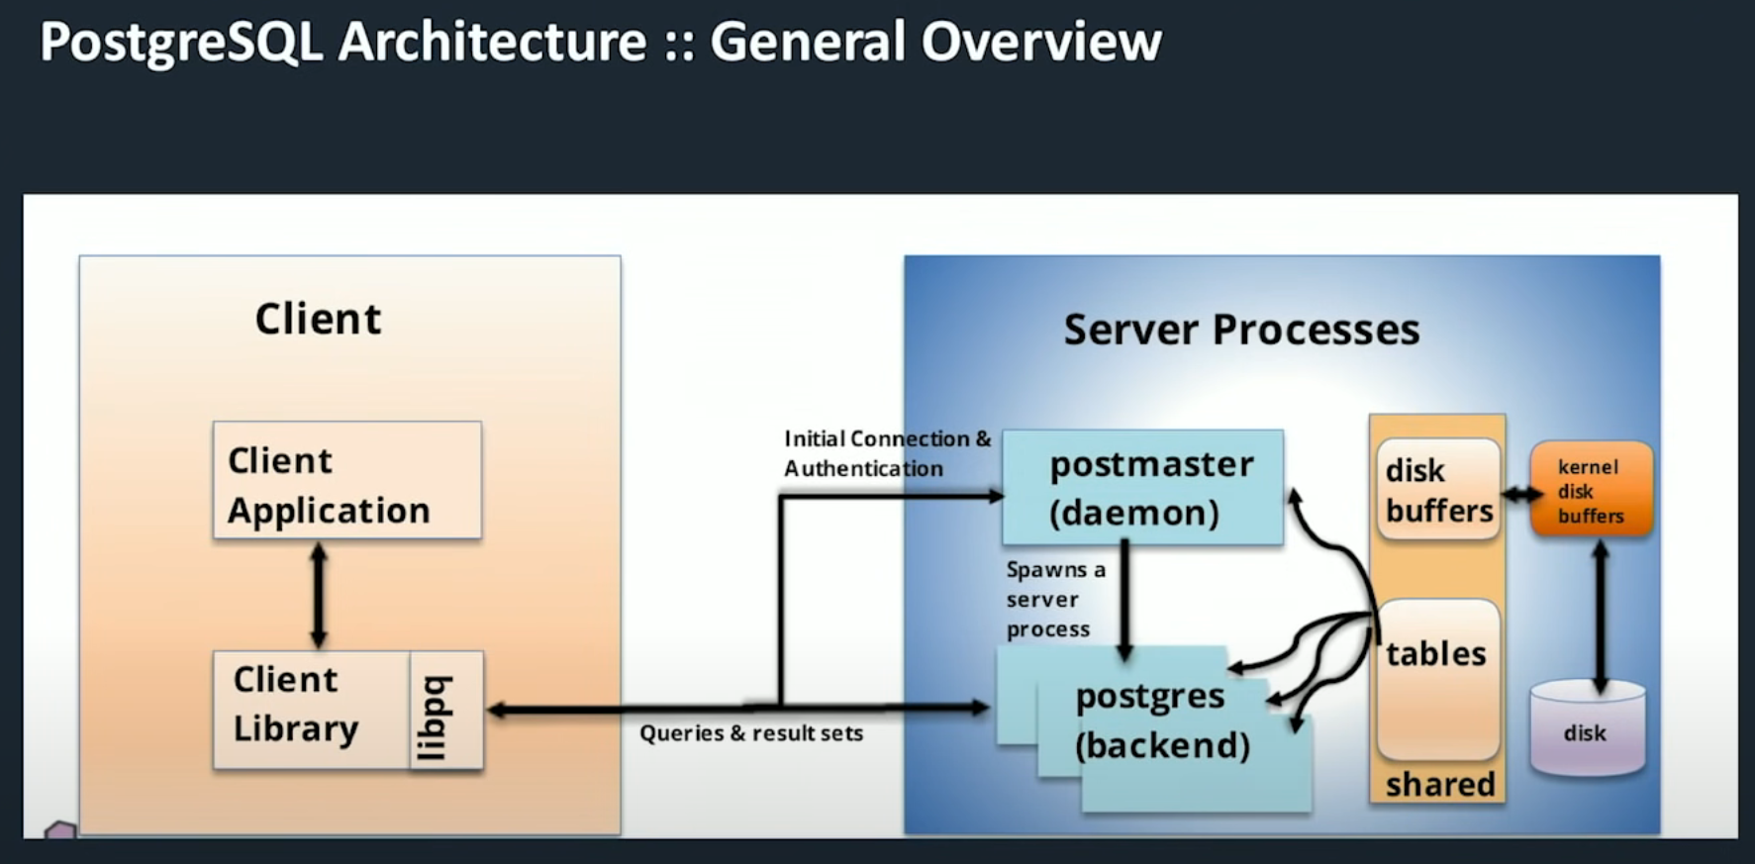

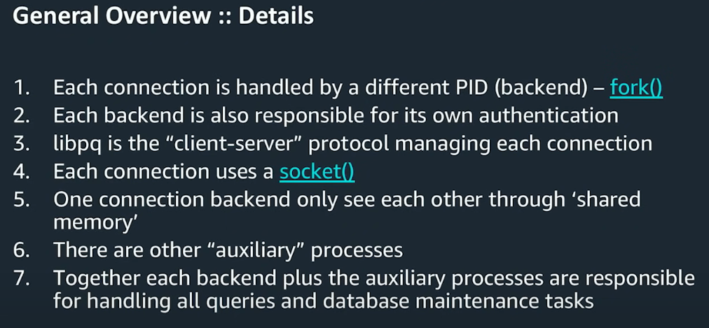

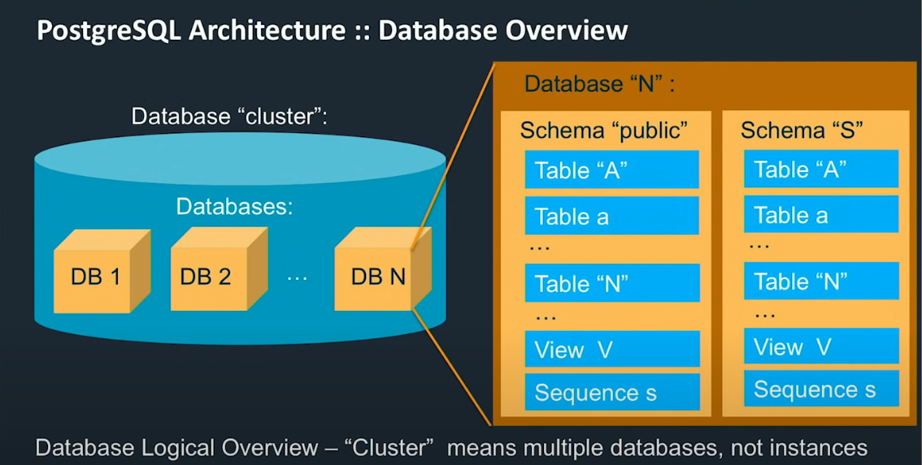

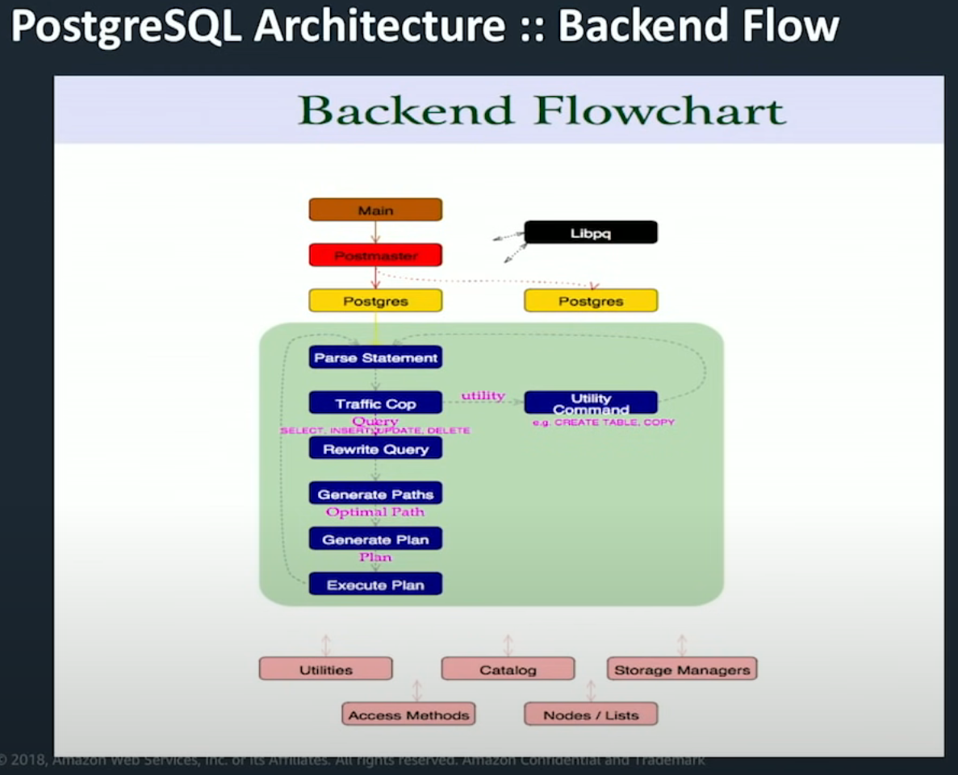

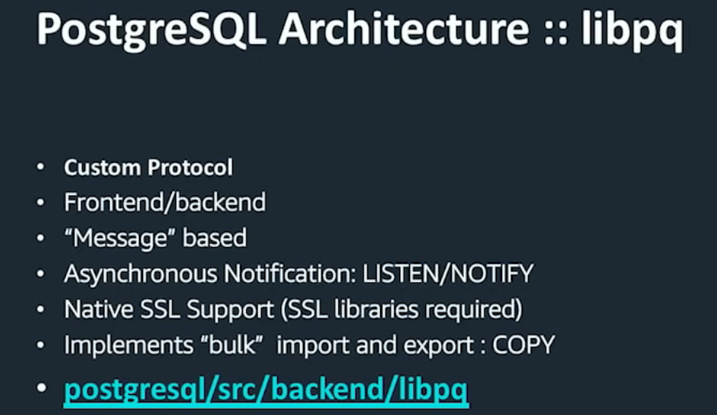

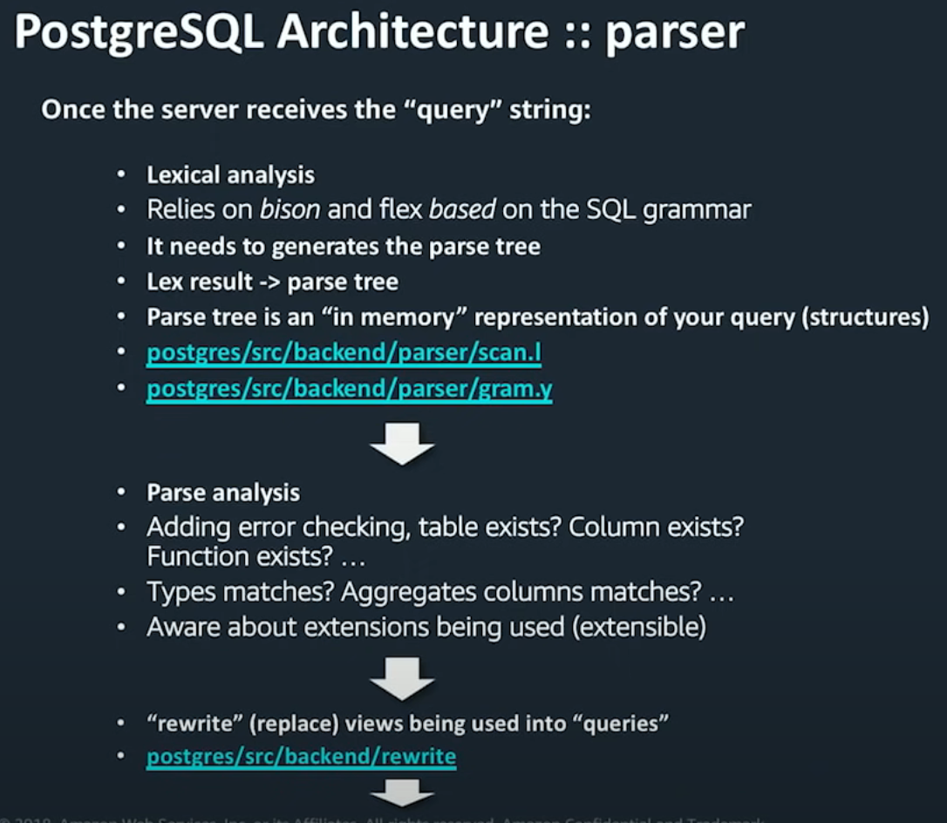

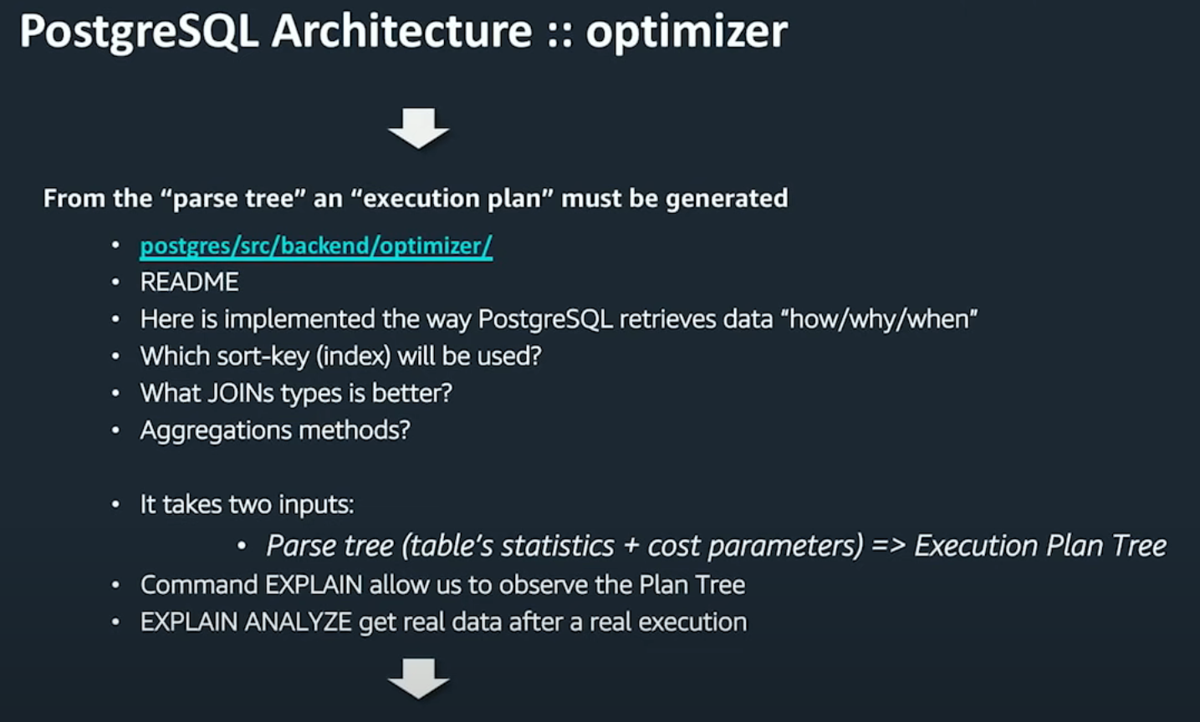

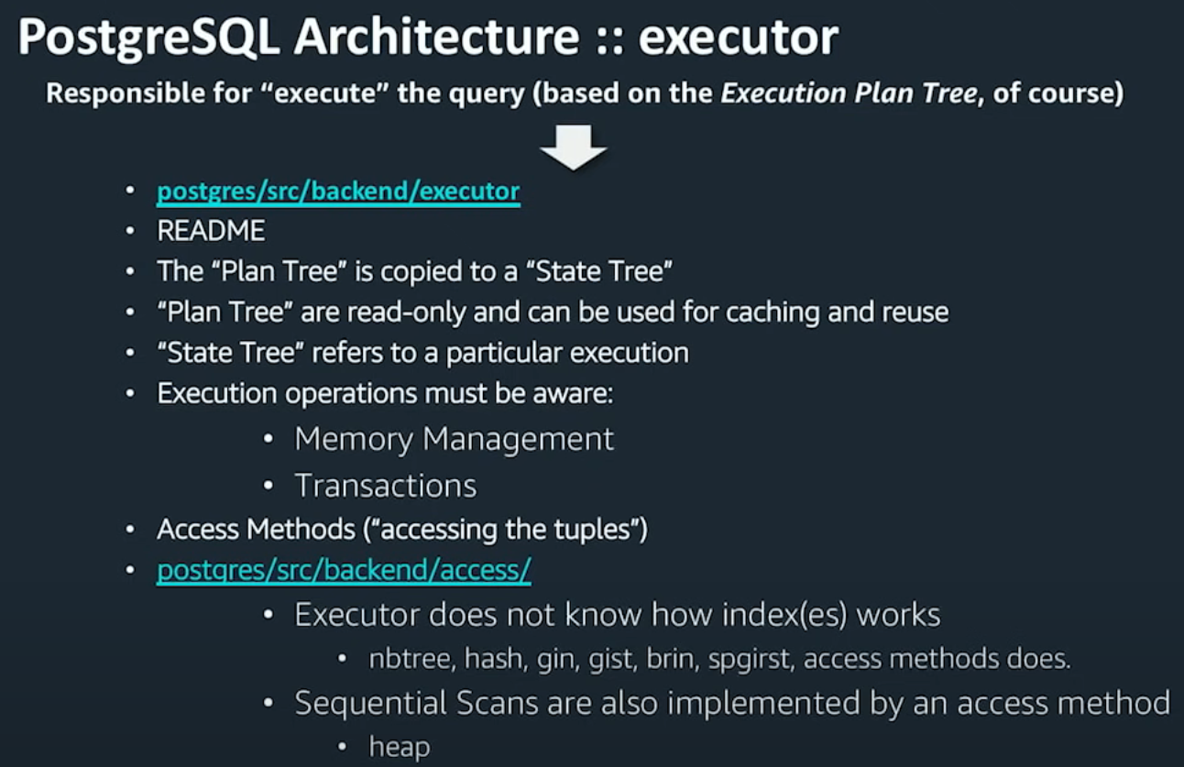

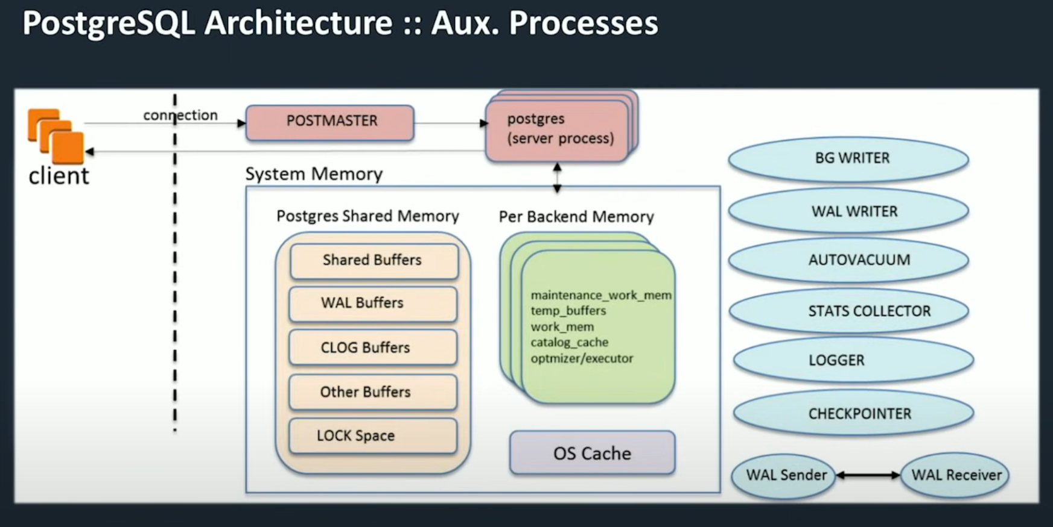

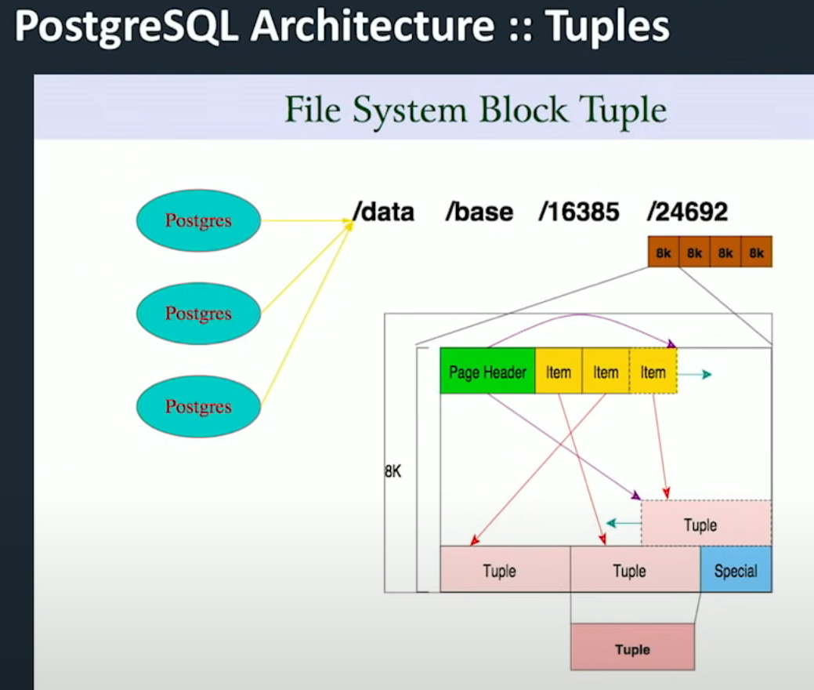

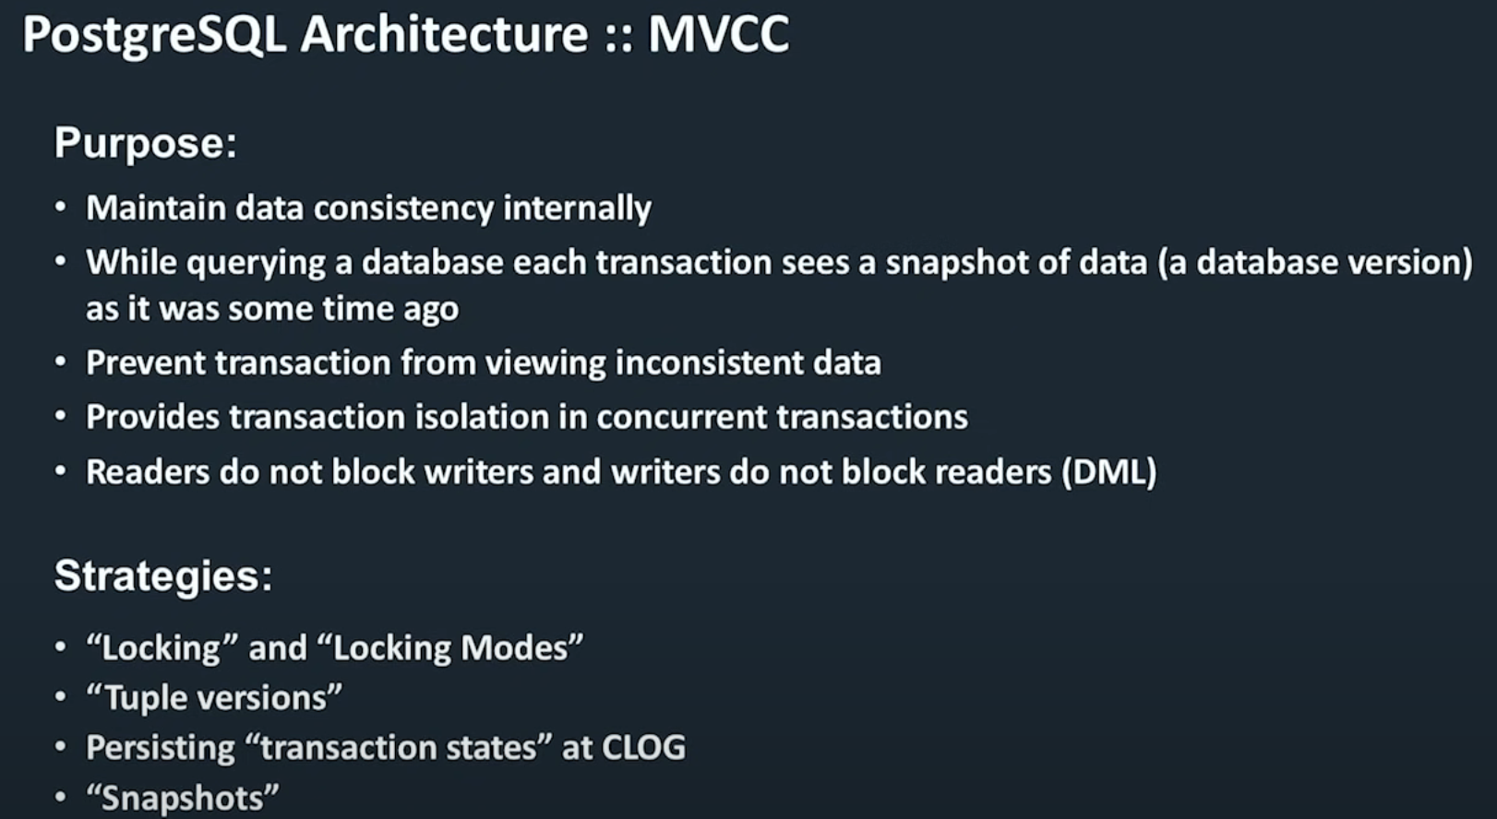

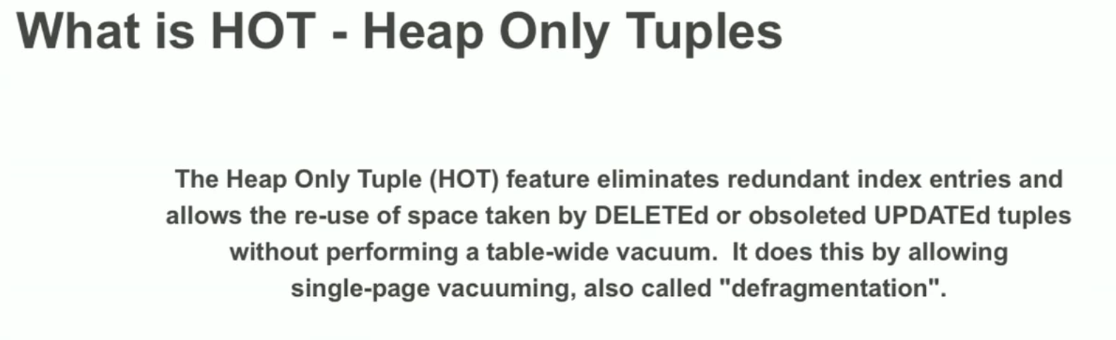

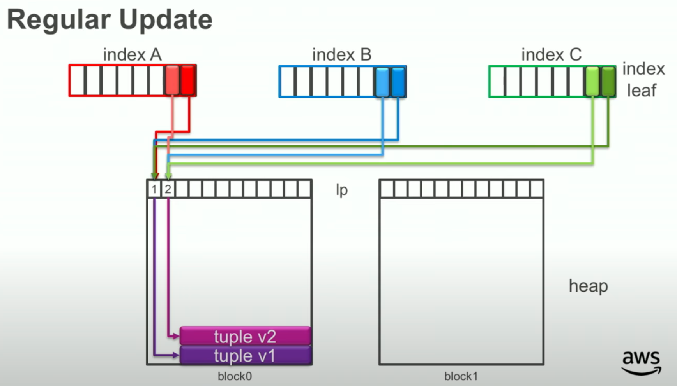

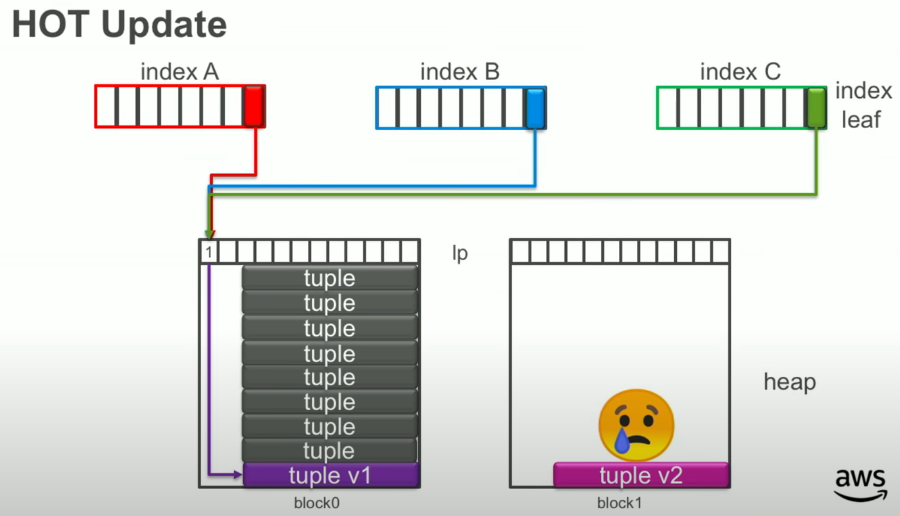

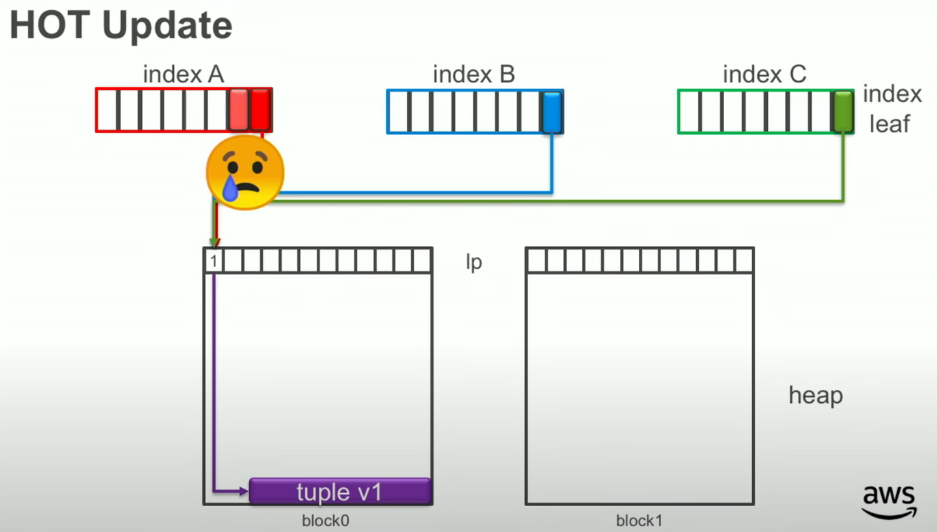

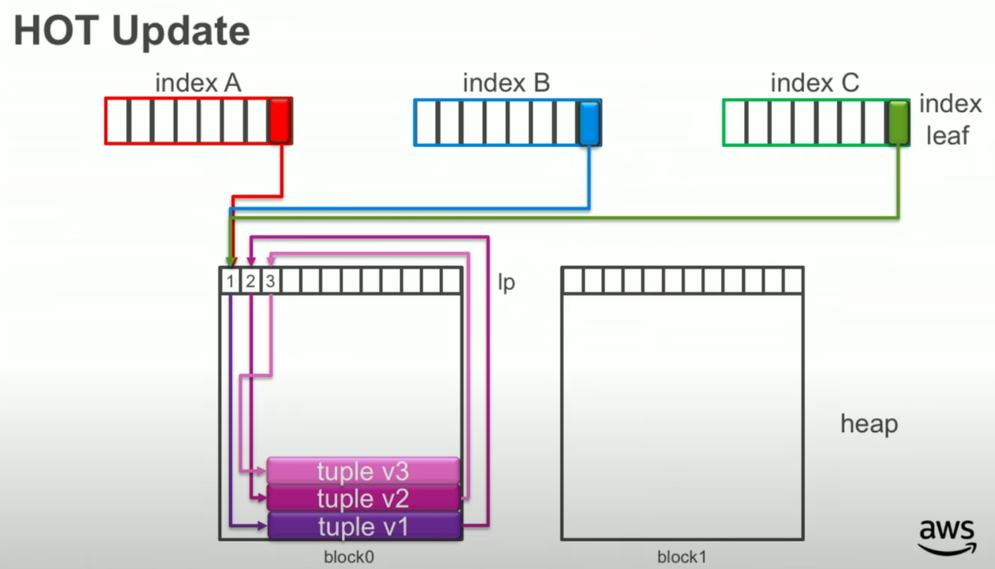

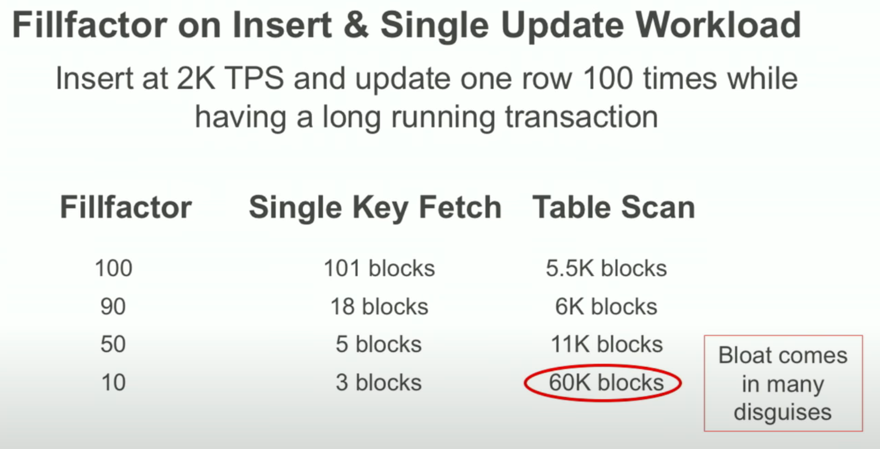

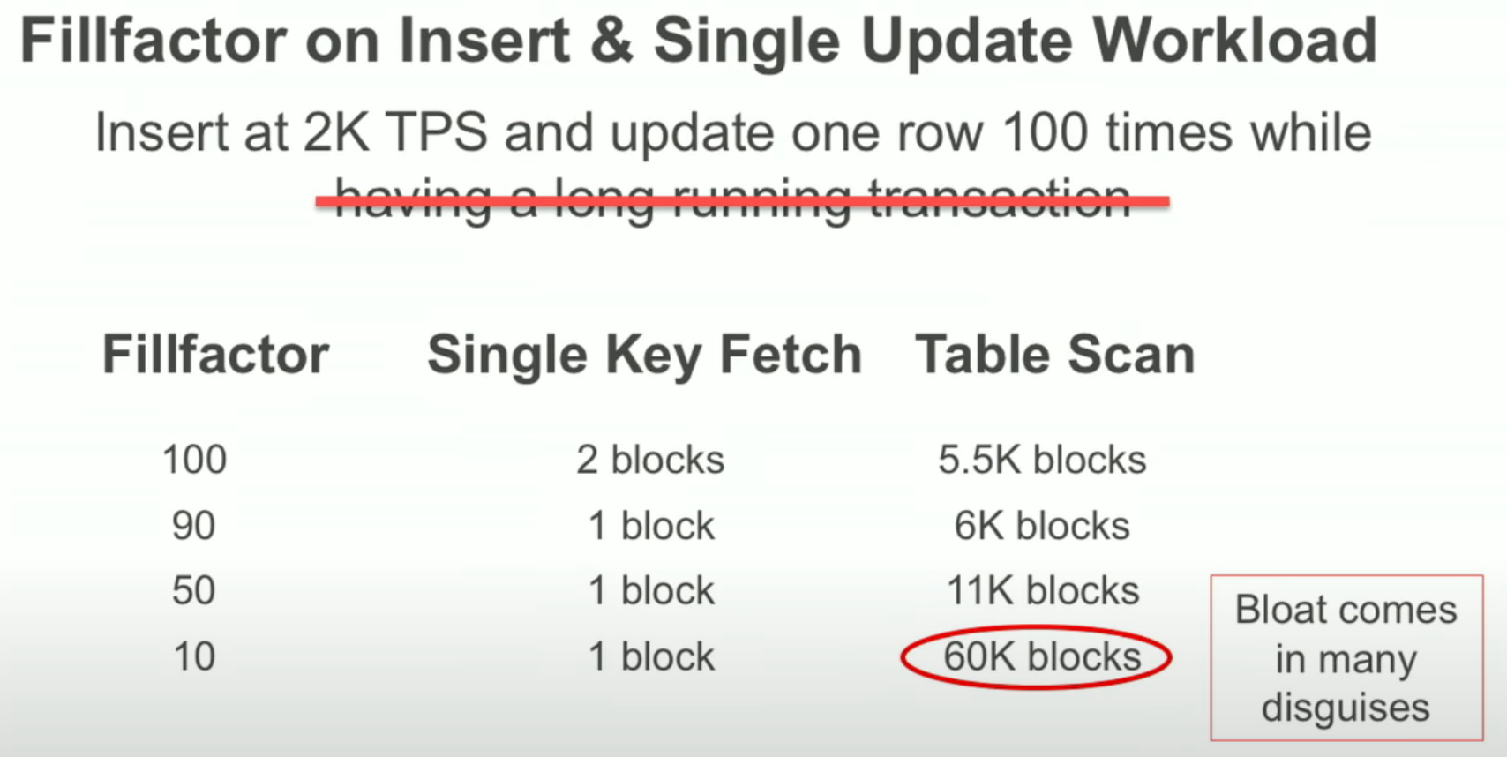

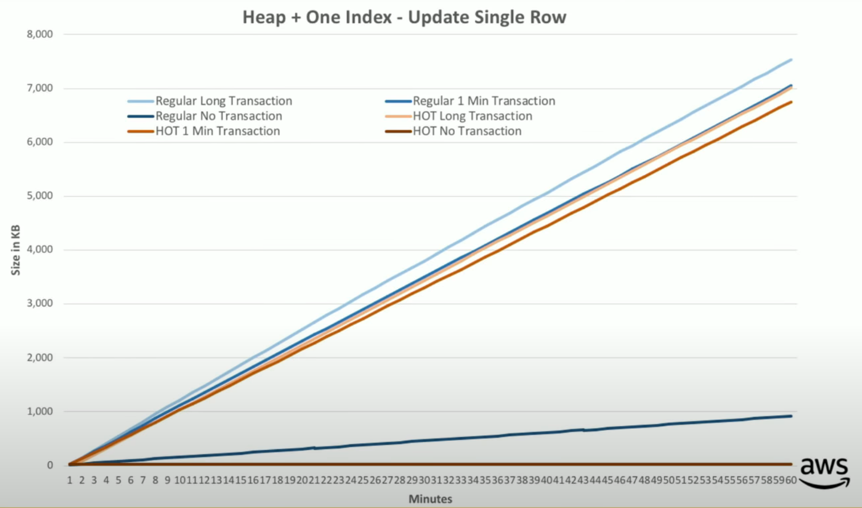

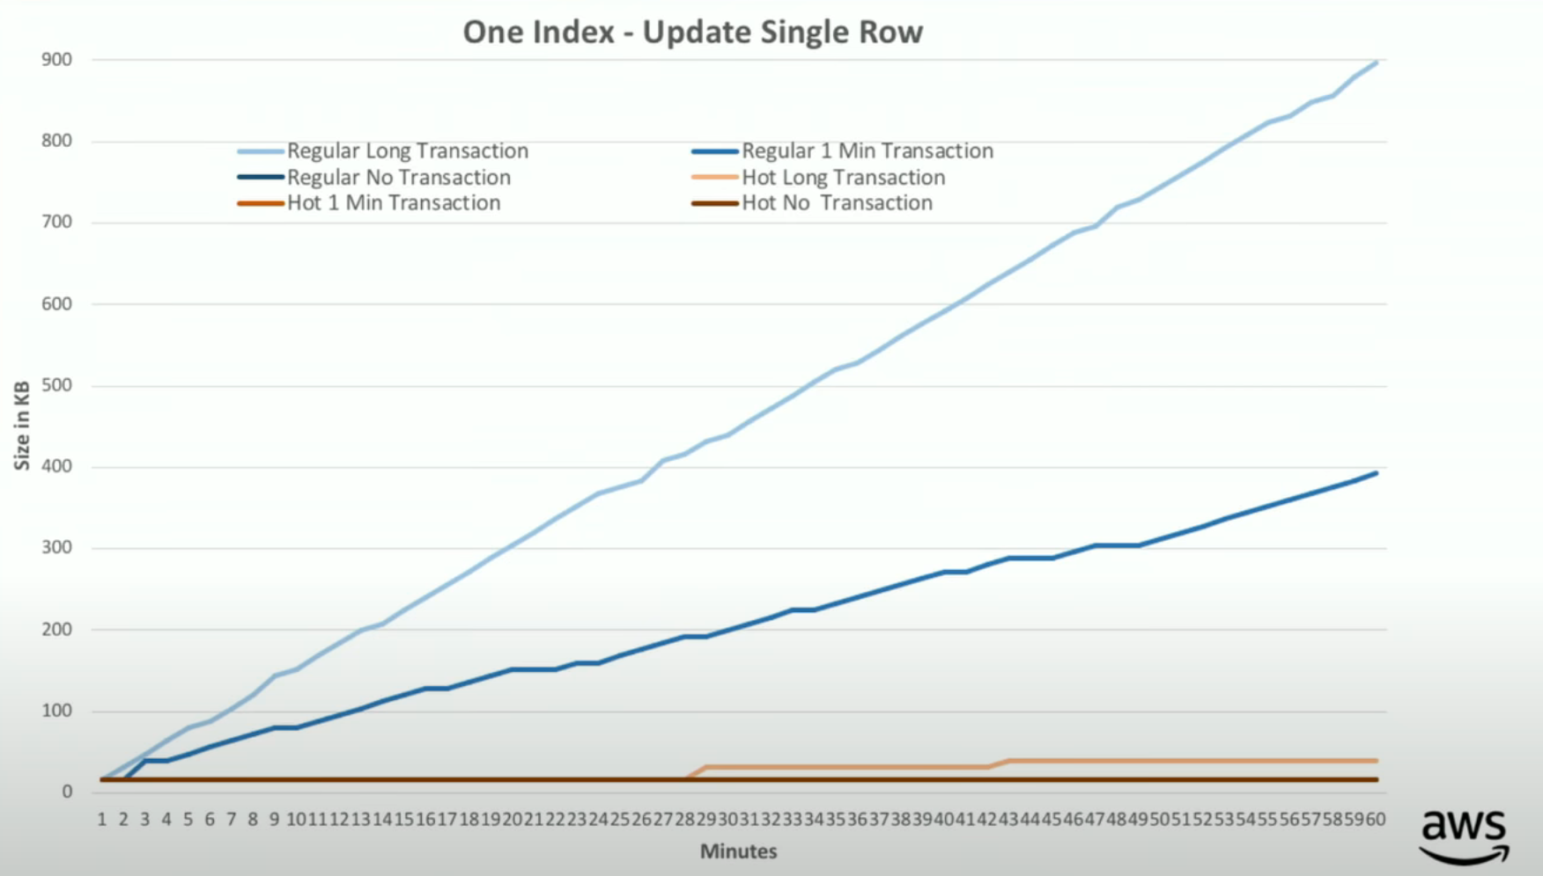

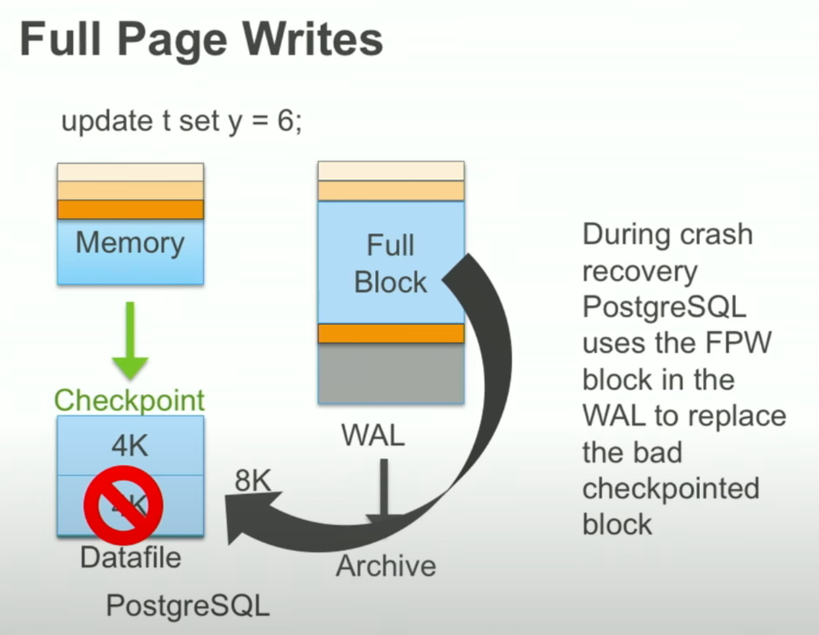

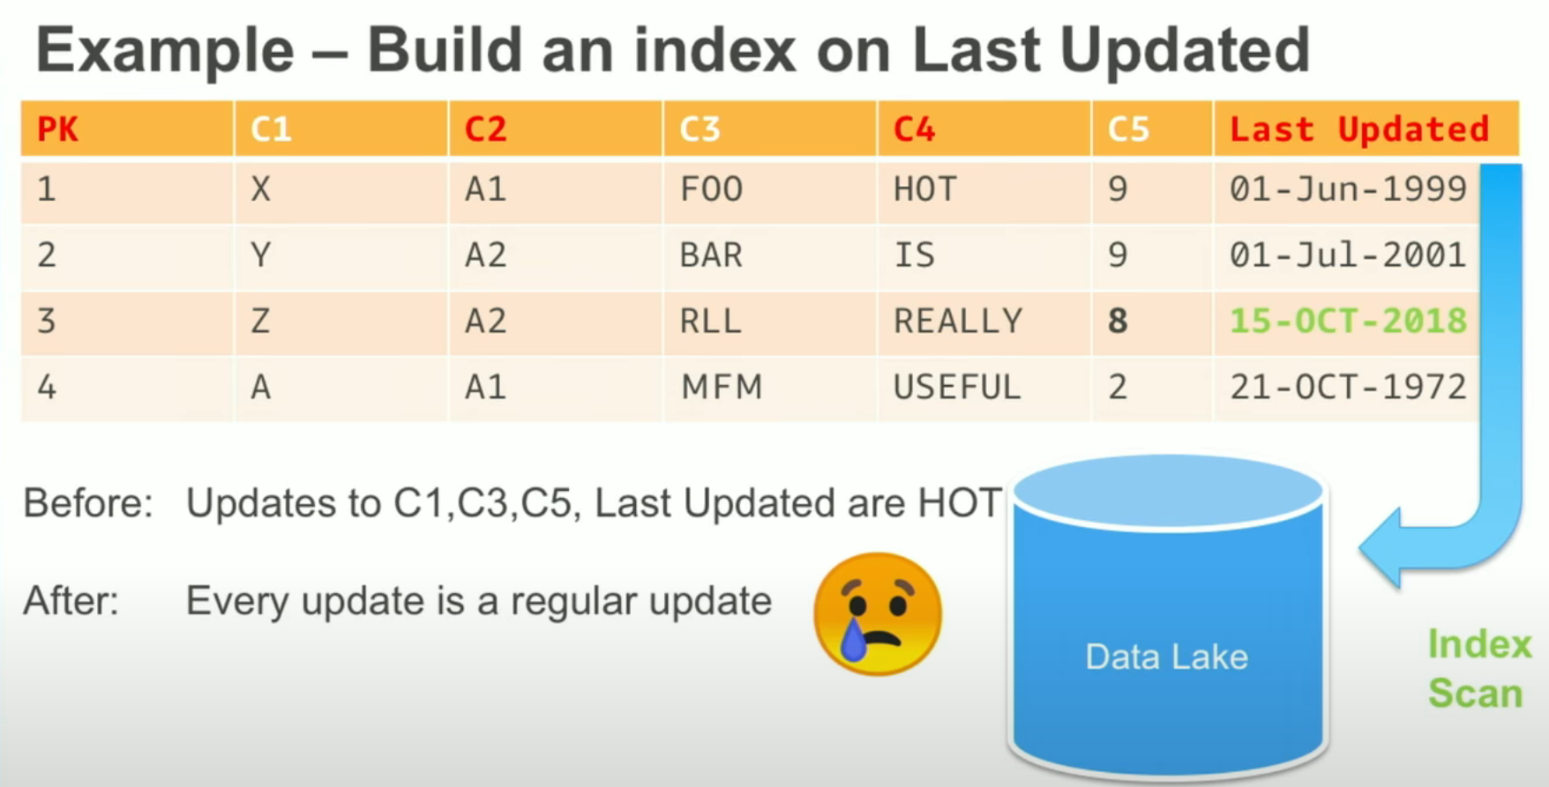

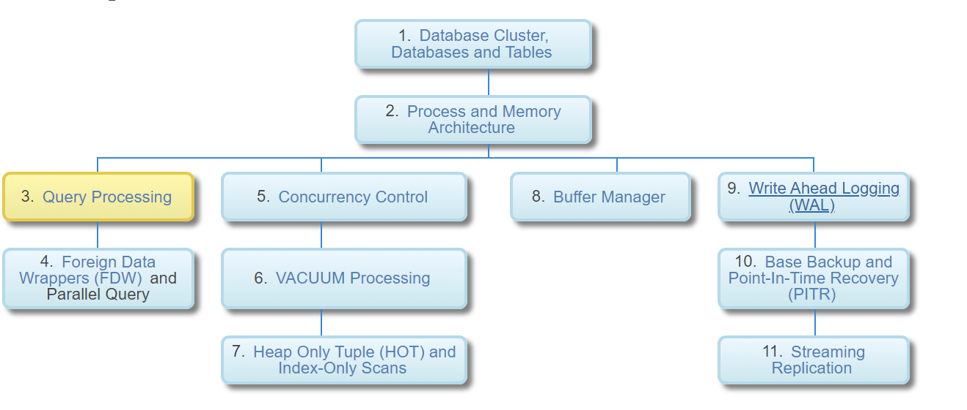

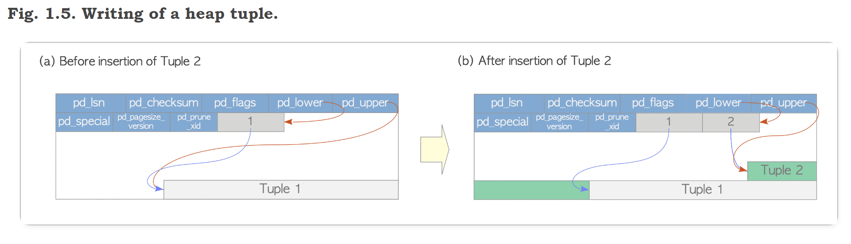

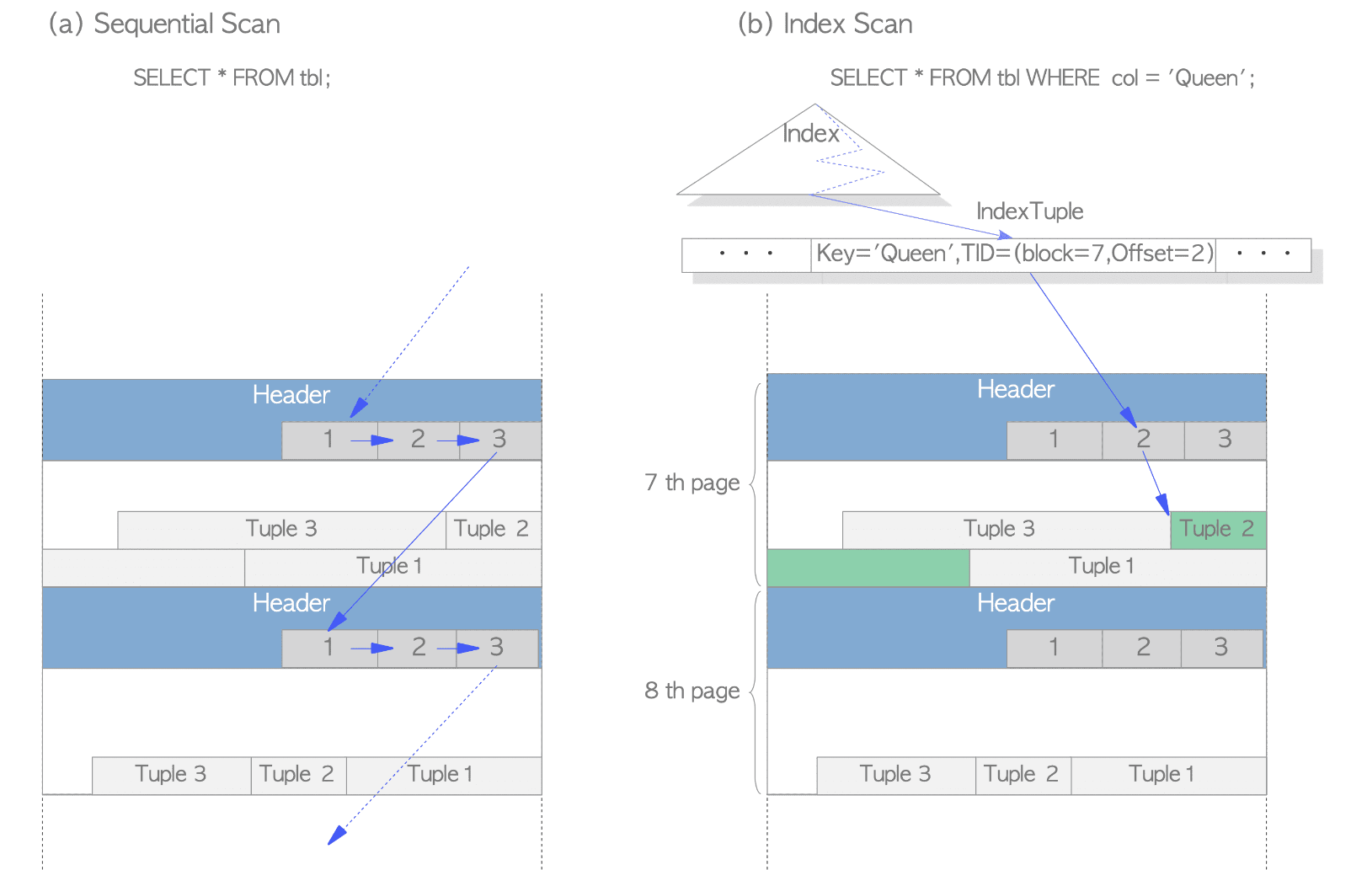

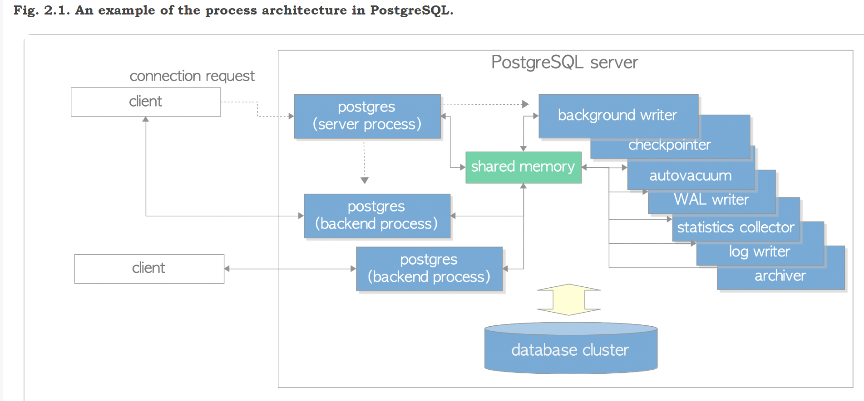

**Memory Architecture**

Memory architecture in PostgreSQL can be classified into two broad categories:

* Local memory area – allocated by each backend process for its own use.

Shared memory area – used by all processes of a PostgreSQL server.

In the following subsections, those are briefly descibed.

**Fig. 2.2. Memory architecture in PostgreSQL.**

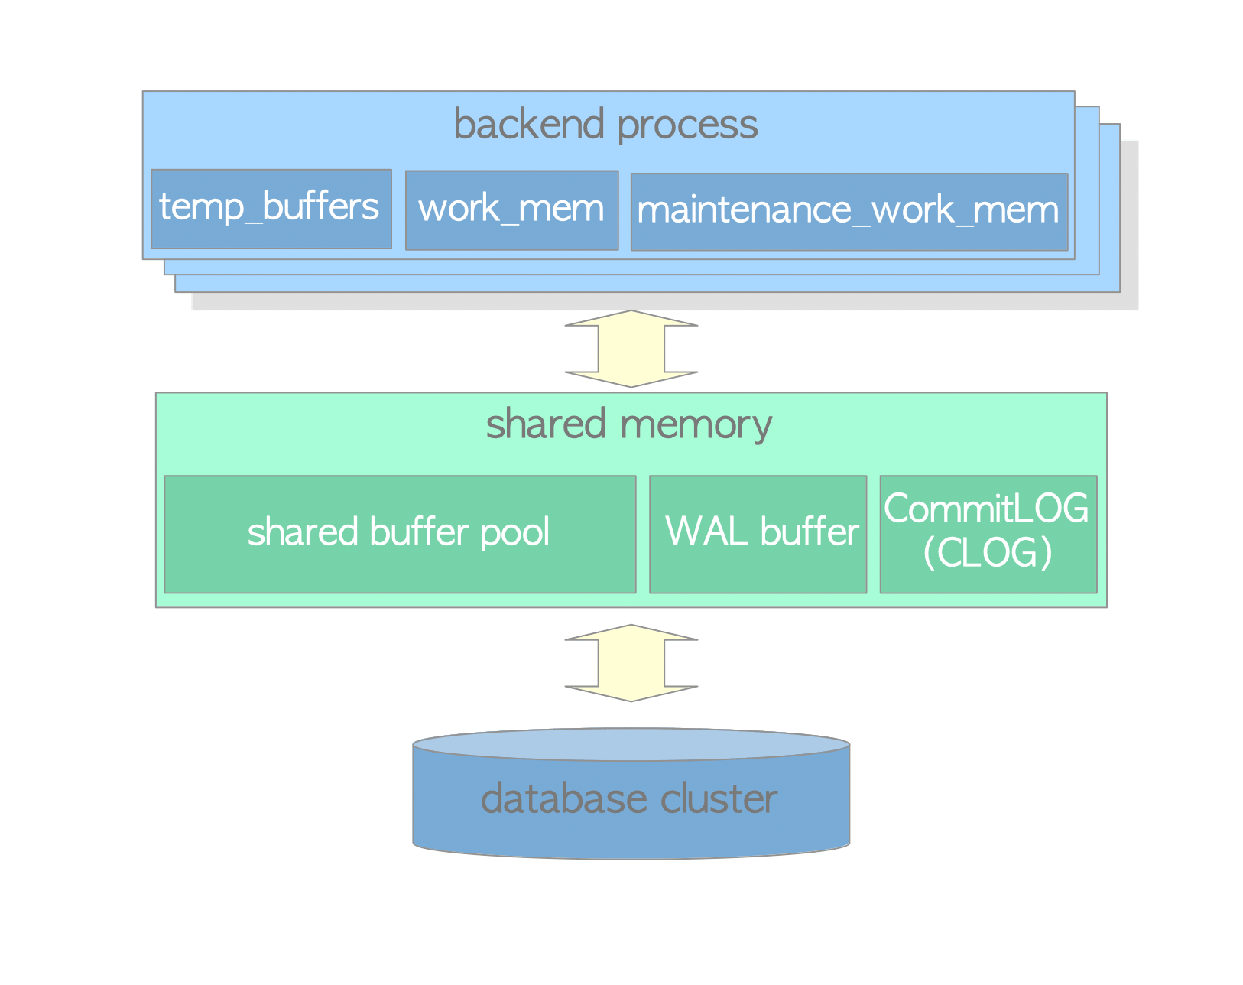

**2.2.1. Local Memory Area**

Each backend process allocates a local memory area for query processing; each area is divided into several sub-areas – whose sizes are either fixed or variable. Table 2.2 shows a list of the major sub-areas. The details will be described in the following chapters.

|  |  |  |
| --- | --- | --- |
| **Table 2.2: Local memory area** | | |
| **sub-area** | **description** | **reference** |
| work_mem | Executor uses this area for sorting tuples  by ORDER BY and DISTINCT operations,  and for joining tables by merge-join and  hash-join operations. | [Chapter 3](https://www.interdb.jp/pg/pgsql03.html) |
| maintenance_work_mem | Some kinds of maintenance operations  (e.g., VACUUM, REINDEX) use this area. | [Section 6.1](https://www.interdb.jp/pg/pgsql06.html#_6.1.) |
| temp_buffers | Executor uses this area for storing temporary tables. |  |

**2.2.2. Shared Memory Area**

A shared memory area is allocated by a PostgreSQL server when it starts up. This area is also divided into several fix sized sub-areas. Table 2.3 shows a list of the major sub-areas. The details will be described in the following chapters.

|  |  |  |
| --- | --- | --- |
| **Table 2.3: Shared memory area** | | |
| **sub-area** | **description** | **reference** |
| shared buffer pool | PostgreSQL loads pages within tables and indexes from a persistent storage to here, and operates them directly. | [Chapter 8](https://www.interdb.jp/pg/pgsql08.html) |
| WAL buffer | To ensure that no data has been lost by server failures, PostgreSQL supports the WAL mechanism.  WAL data (also referred to as XLOG records) are  transaction log in PostgreSQL;  and WAL buffer is a buffering area of the WAL data before writing to a persistent storage. | [Chapter 9](https://www.interdb.jp/pg/pgsql09.html) |
| commit log | Commit Log(CLOG) keeps the states of all transactions (e.g., in_progress,committed,aborted) for Concurrency Control (CC) mechanism. |  |